Project Documentation

Project Title:
An employee requests installation of licensed software through the Service Catalog

Name: Nakka Harshavardhan
College: Nadimpalli satyanarayana Raju Institute of Engineering and Technology
Email: 23nu1a0544@nsrit.edu.in

Project Overview:
This project automates the end-to-end software request lifecycle in ServiceNow to eliminate manual processing delays and tracking errors. It features a standardized Service Catalog item with custom input variables for seamless request submission. Automated approval routing and IT task generation are managed through dynamic workflows and Flow Designer. Additionally, custom Business Rules handle licensing exceptions automatically, while Update Sets ensure smooth deployment across different environments.

Table of Contents:
1. Introduction
2. Project Objectives
3. Key Features
4. ServiceNow Developer Setup
5. Project Implementation in ServiceNow
6. Conclusion

1.Introduction:

In an organization, employees often need different software applications for their work. Traditionally, employees may request software installation through emails or direct communication with the IT team. This can cause delays, lack of tracking, and difficulty in managing requests.
The Software Installation Request Automation project is developed using ServiceNow to provide a centralized and automated way for employees to request software installation.
The employee submits a software request through the Service Catalog by providing details such as software name, version, justification, and urgency. The system creates a Request and Requested Item (REQ/RITM), performs approval through Flow Designer, and automatically creates a Catalog Task (SCTASK) for the IT/Software Support team.
The project helps IT teams manage software installation requests efficiently and provides better visibility into the request status.

2. Project Objectives:

The main objective of the Software Installation Request Automation in ServiceNow project is to provide a centralized Service Catalog where employees can easily submit software installation requests. The system automates the approval process, creates and assigns fulfillment tasks to the appropriate IT/Software Support team, and allows employees to track their request status. It also handles exceptions such as software license shortages by automatically creating incidents when a request is placed on hold. Overall, the project aims to reduce manual work, minimize delays, improve transparency, and provide an efficient and organized software installation process.

3. Key Features:

S.No. | Feature | Description
1 | Service Catalog Item | Employees can request licensed software through the Service Catalog.
2 | Software Details | Employee provides software name, version, and justification.
3 | Urgency | Employee selects the urgency level of the request.
4 | Request Creation | ServiceNow automatically creates REQ and RITM records.
5 | Approval | The request goes through an approval process.
6 | Flow Designer | Automates the request processing workflow.
7 | Catalog Task | Creates an SCTASK for software installation.
8 | Assignment Group | Task is automatically assigned to the Software Support group.
9 | Request Tracking | Employee and IT can track request/task status.
10 | Exception Handling | On-hold requests can be handled through automation/Business Rules.
11 | Update Set | Project configuration can be packaged for deployment.

4. ServiceNow Developer Setup:
Create a Developer Account
1. Go to ServiceNow Developer Portal(https://developer.servicenow.com/dev.do).
2. Sign up for a free developer account and fill out the following details.
3. After signing up, you will get a verification mail to your provided email id. After the verification your ServiceNow Developer Portal Home Page will appear.
4. Now click on start building it will take you to the section where you can request a Personal Developer Instance (PDI) or start using App Engine Studio and other tools.

5. Project Implementation in ServiceNow:

After the instance building is completed, the page will be directed to your creator studio. Creator Studio in ServiceNow provides a guided. No code environment to build applications quickly. It is especially useful for creating request based applications by defining forms, setting up tables, and automating workflows.
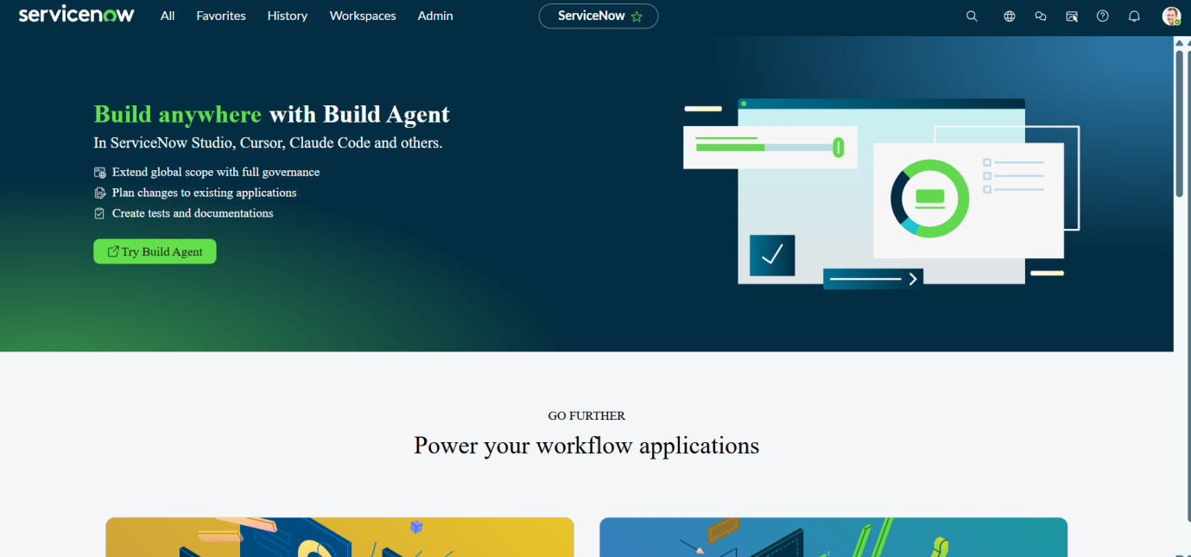

Milestone 1: Update Sets
Objective: The objective of using Update Sets in ServiceNow is to capture, package, and migrate customizations or configurations
Activity 1: Creating an update set
1. Open ServiceNow Instance(PDI).
2. Click on All >> search for Local Update sets
3. Select Local Update sets
4. Create new update set record
5. Give an update set name as ‘Software Installation Request Setup’
6. Make State is In-progress and click on Submit and make Current.

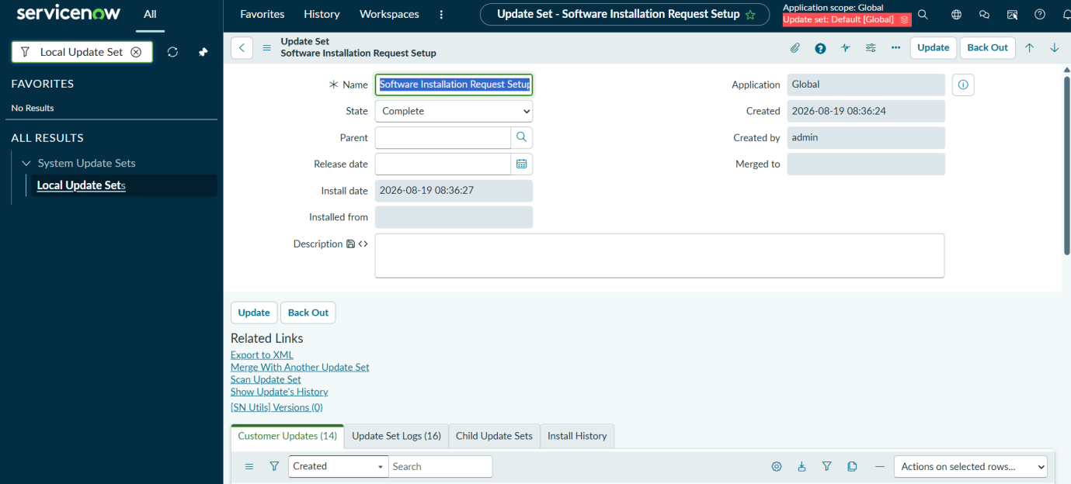

Milestone 2: Service Catalog
Activity 1: Creating Catalog item
1. Open ServiceNow Instance.
2. Click on All >> search for Maintain items.
3. Click on New and Fill the details as given below.
4. Give a Suggestion Name in Meta (so that you can search easily).
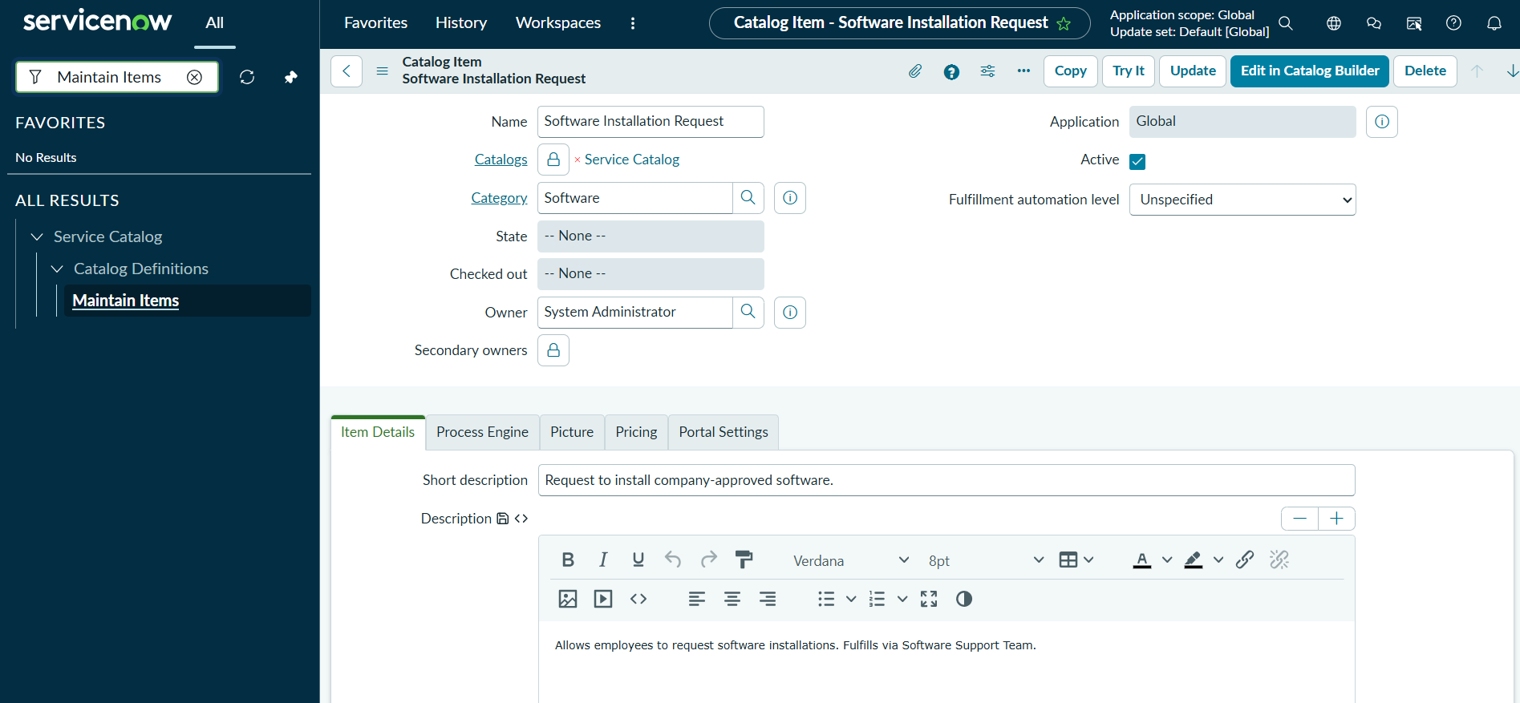

Activity 2: Creating Catalog Variables
5. After saving the catalog item Scroll Down and Click on Variables
6. Click on New and Create four Variables as per given below
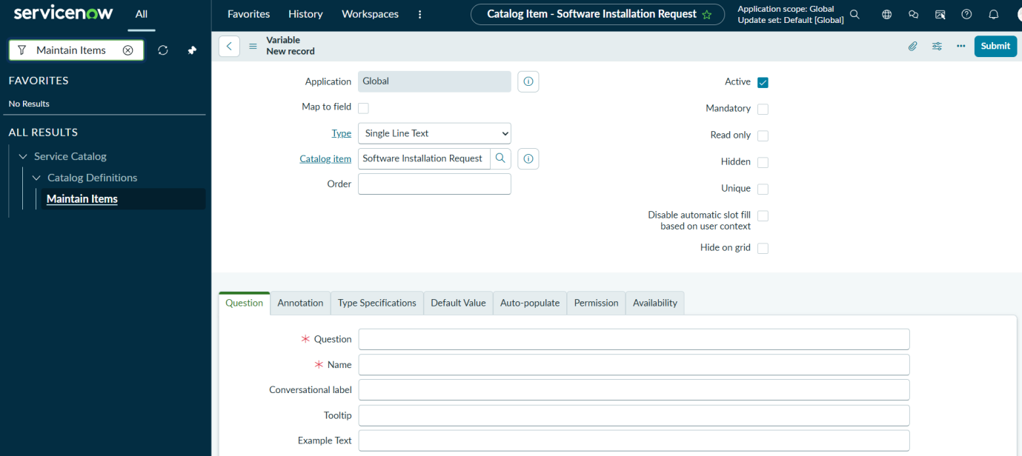

The Four Variables are:

Variable 1: Software Name
Type: Single Line Text
Question: What software do you need?

Variable 2: Version Required
Type: Single Line Text
Question: Specify version (if required).

Variable 3: License Justification
Type: Multi Line Text
Question: Why do you need this software?

Variable 4: Urgency
Type: Choice (Options: Normal, High, Critical)
Question: Select urgency level.

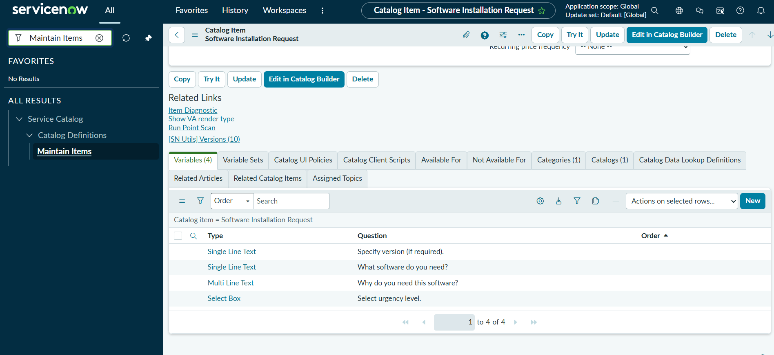

Testing: Testing Catalog variables
8. Click on try it .
9. You can see the variables which you have created.
10. Fill the details as per given below.
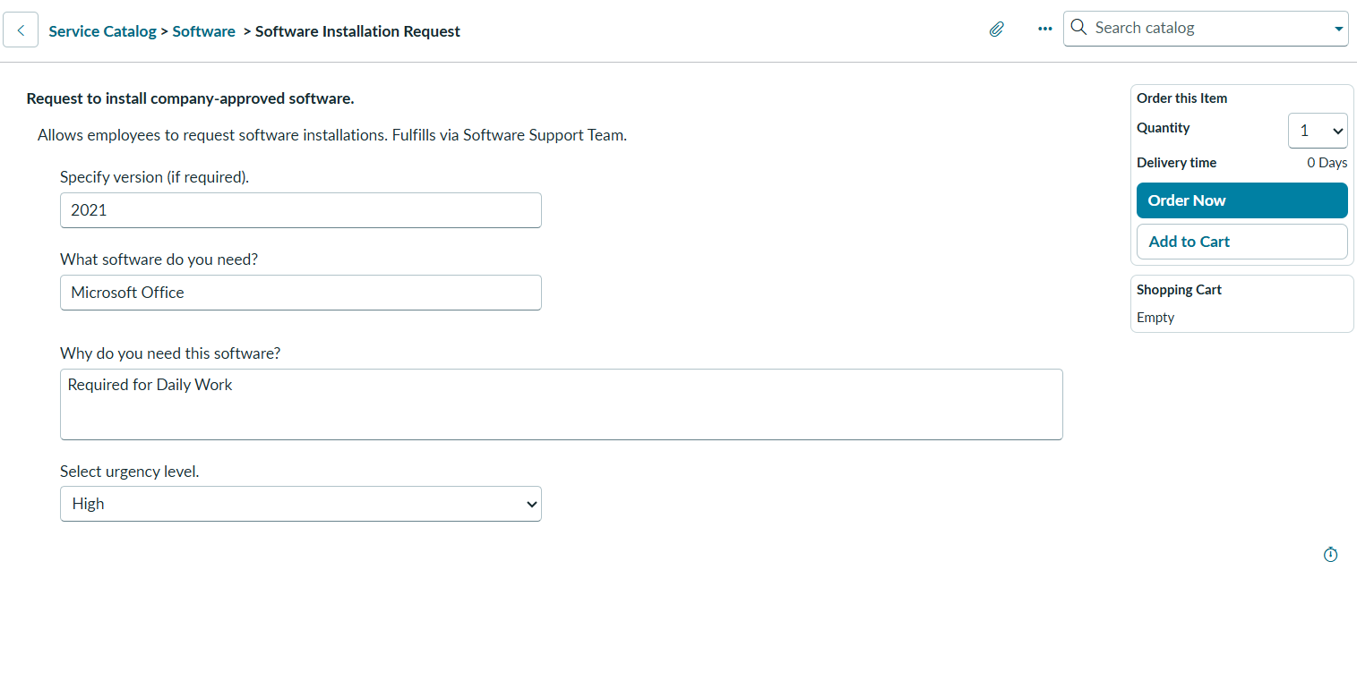
11. Click on order now.
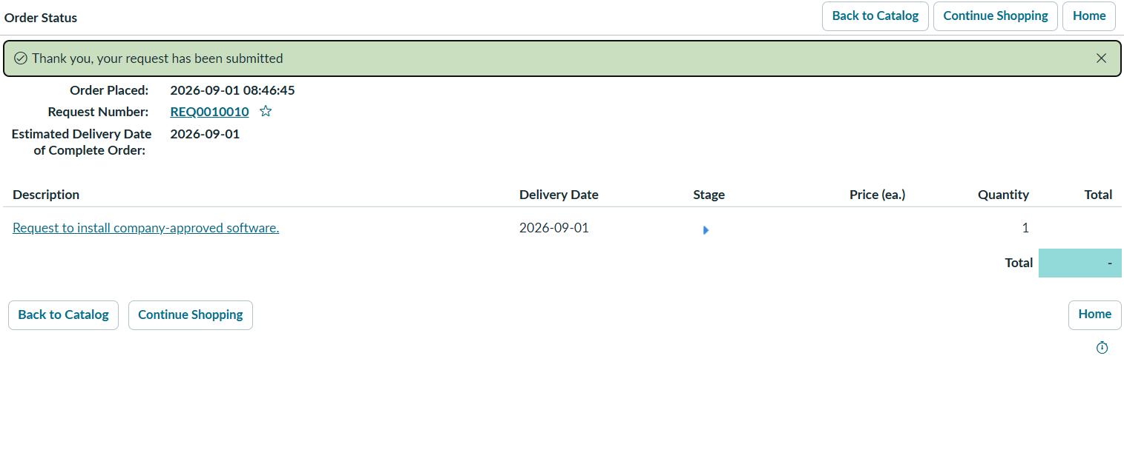
Milestone 3: WorkFlow
Activity 1: Creating the Flow
- Open ServiceNow instance.
- Navigate to All > Process Automation > Flow Designer.
- Click New (top right) and select Flow.
- Configure the Flow Properties:
  - Flow Name: Software Request Flow
  - Description: Automation for software installation requests.
- Click on Build Flow.

The screenshot is for to create a flow:
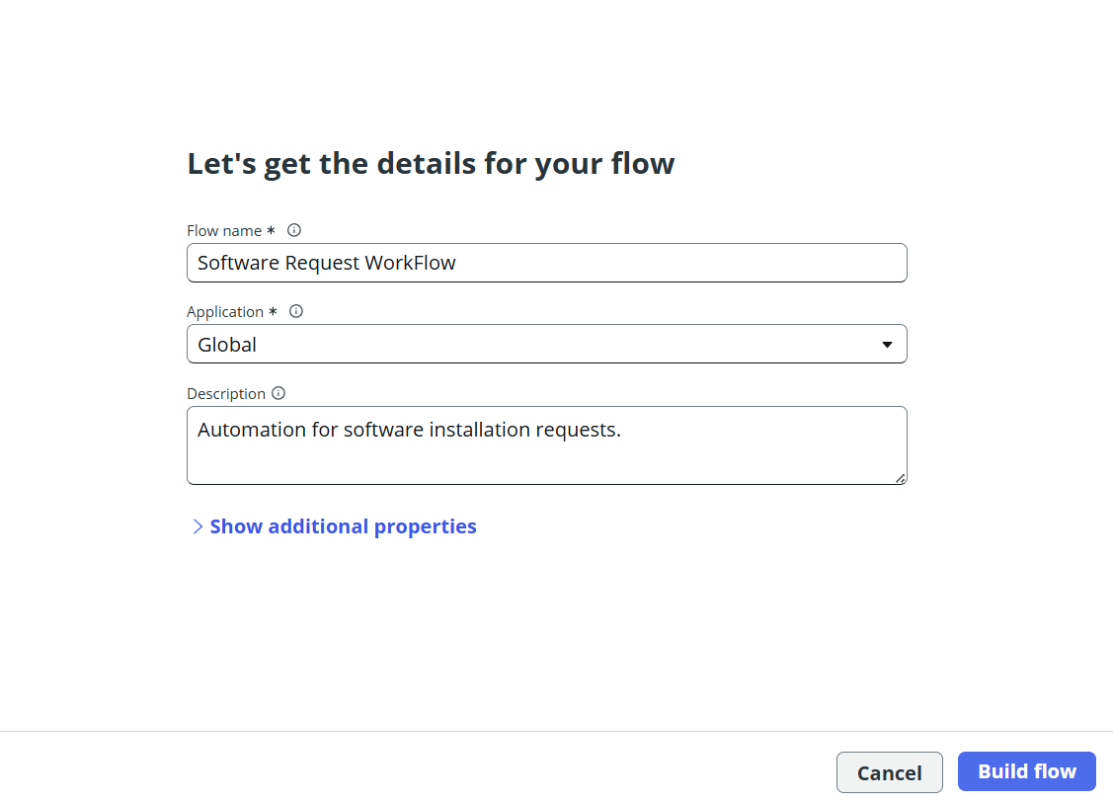

Activity 2: Designing the Flow Logic & Actions
Step 1: Set Up the Trigger
- Click Add a Trigger.
- Under the Service Catalog section, select Service Catalog.
- Click Done.
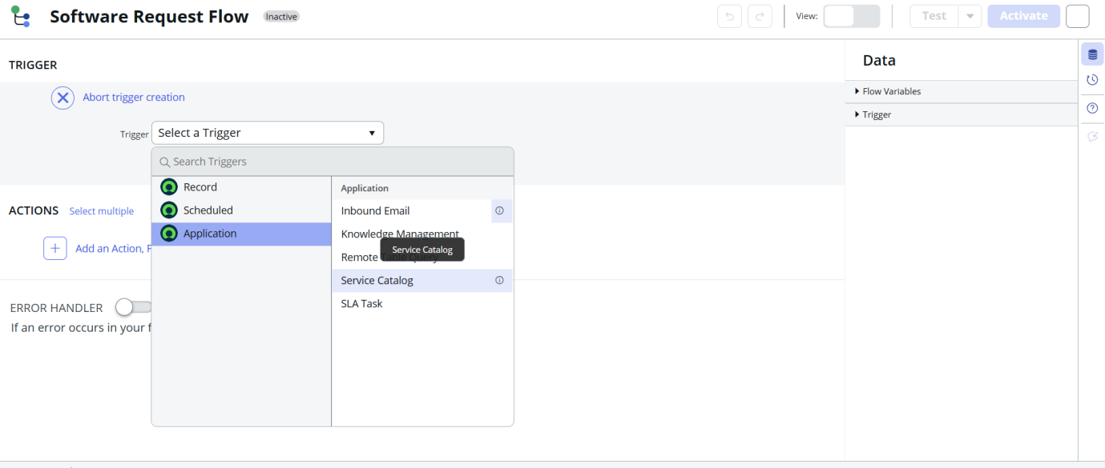

Step 2: Add Manager / Group Approval Action
- Click Add an Action, Flow Logic, or Subflow $→$ select Action.
- Search for and select Ask For Approval under ServiceNow Core.
- Record: Drag and drop the Requested Item Record pill from the right-hand Data Panel into the Record field.
- Approval Conditions:
  - Set condition to Approve when $→$ Anyone approves.
  - Select the designated group (e.g., Software Support).
- Click Done.
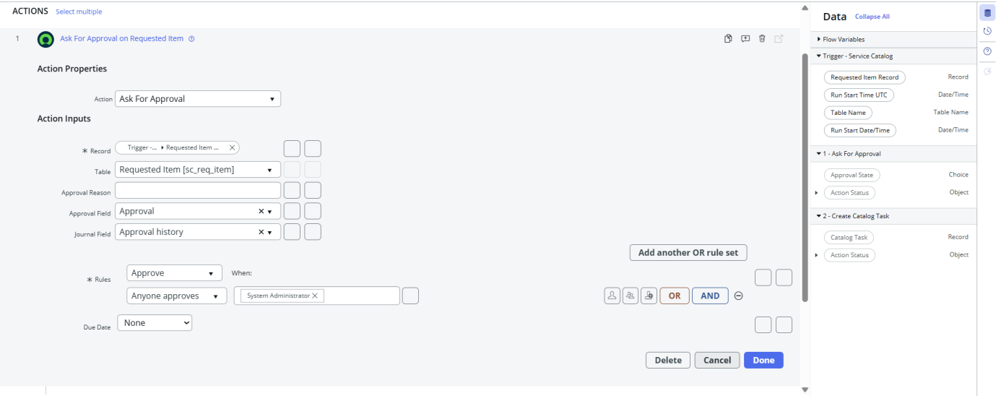
Step 3: Add Catalog Task Creation Action
- Click the + icon below the approval step and select Action.
- Search for and select Create Catalog Task.
- Requested Item: Drag and drop the Requested Item Record pill from the Data Panel.
- Fields Configuration:
  - Short Description: Fulfill Software Installation Request
  - Assignment Group: Software Support
- Click Done.
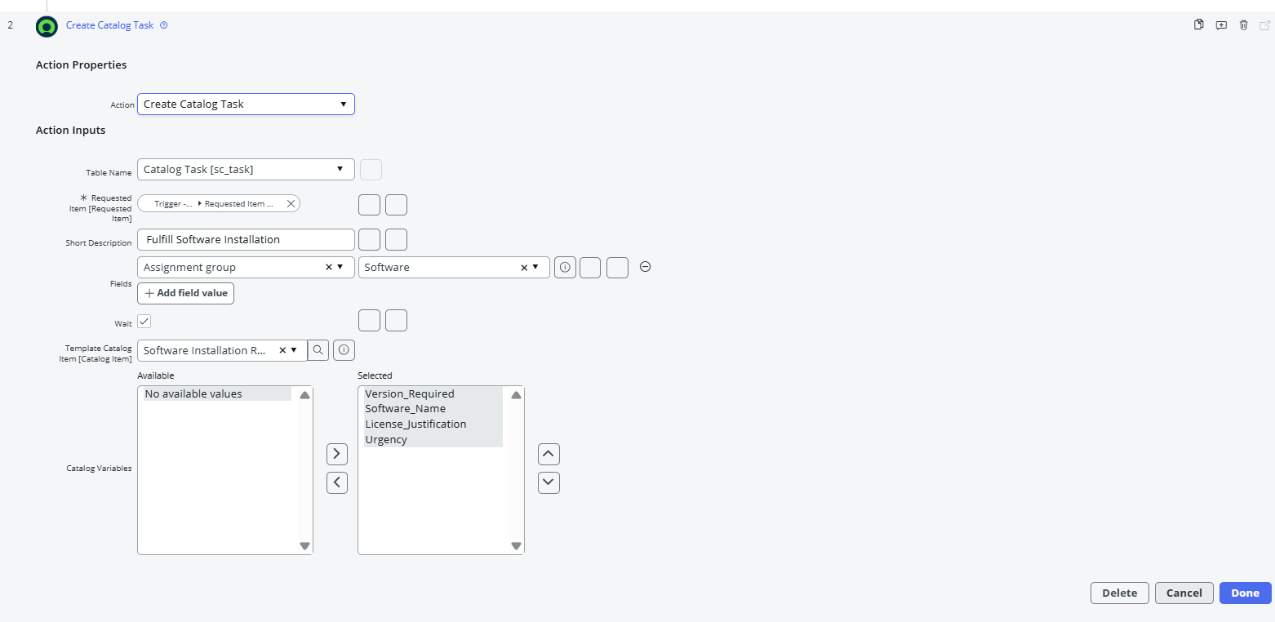
Step 4: Save & Activate
- Click Save in the upper right control bar.
- Click Activate to publish the flow for production use.
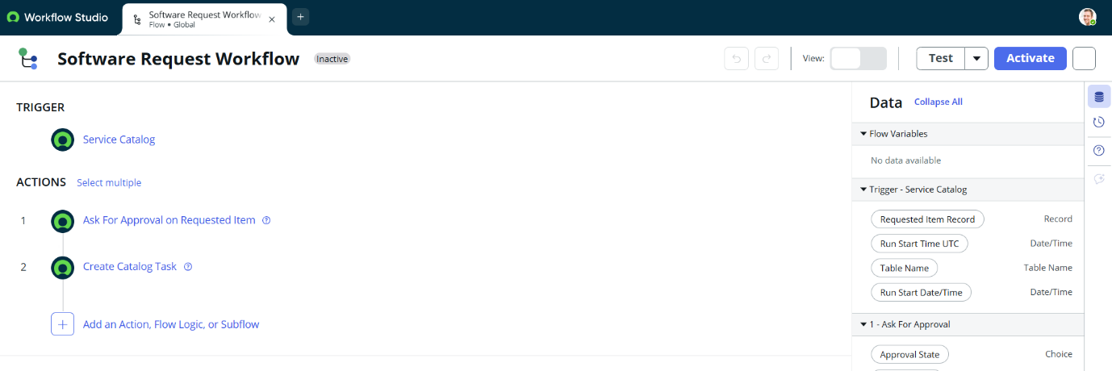

Milestone 4: Attaching Process Automation to Catalog Item
- Navigate to All > Service Catalog > Catalog Definitions > Maintain Items.
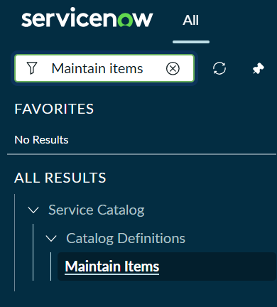
- Open your Catalog item: Software Installation Request.
- Select the Process Engine tab.
- Clear the legacy Workflow field if any value exists.
- In the Flow field directly below it, search for and select Software Request Workflow.
- Click Save or Update.
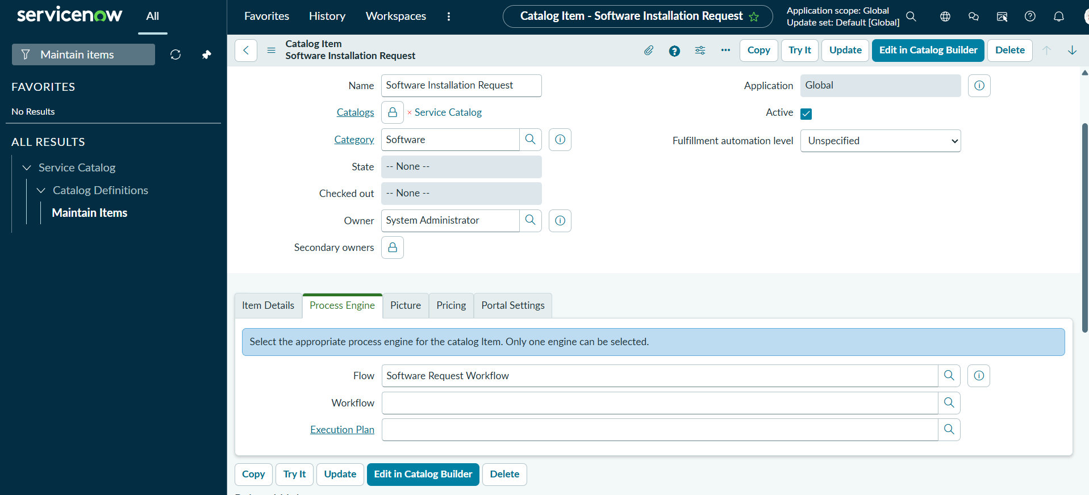

Milestone 5: Tables Handling

Activity 1: sc_request Table (Service Catalog Request Table)
1. Open ServiceNow Instance
2. Search for Service Catalog > Requests
3. Request Number

Testing: Testing catalog Requests, Items, Tasks
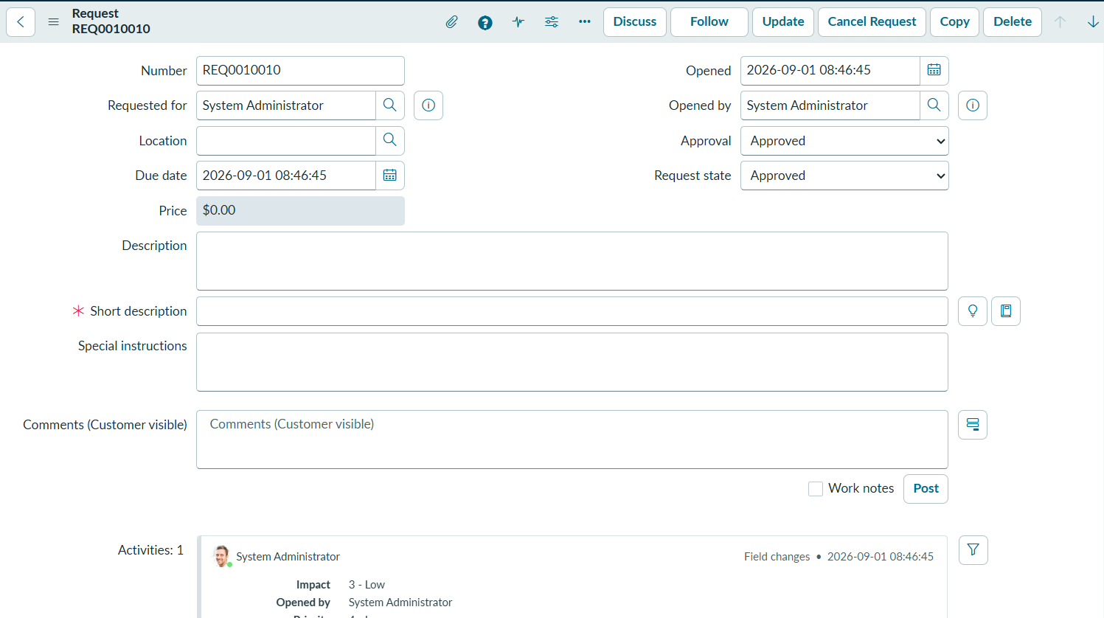

Activity 2: sc_req_item Table (Requested Item Table)
1. Under the service catalog requests click on items
2.open the request item number
3. you can see the catalog item variables with backend names are auto filled.
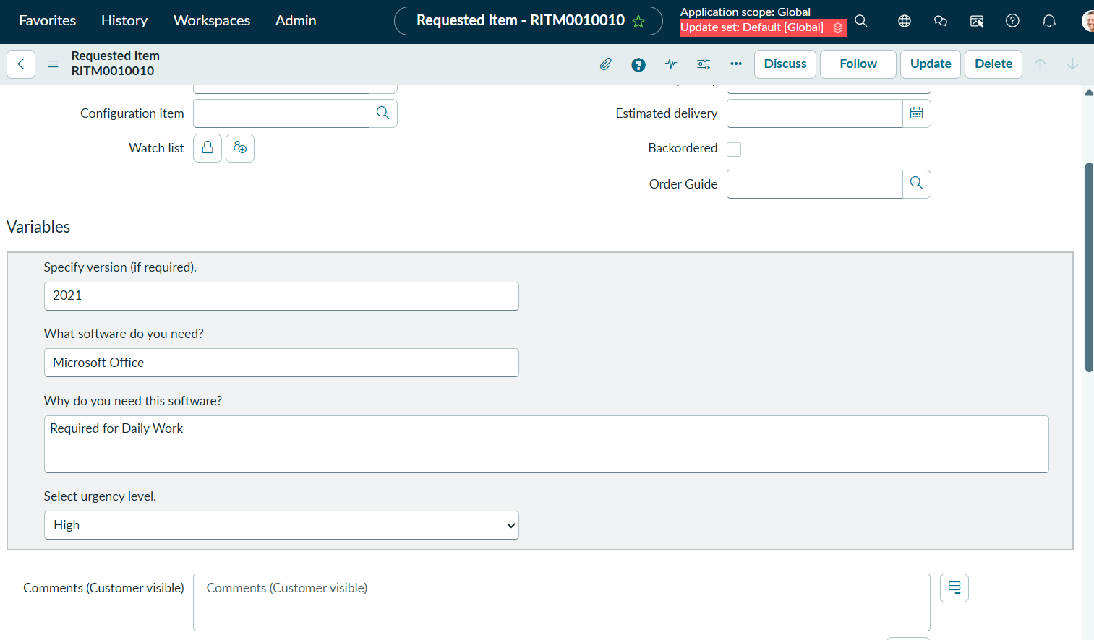

Activity 3: sc_task Table (Catalog Task Table)
- Do the same process for task table
- Open and verify:
● Task assigned to Software Support Team
● Short Description (like Install Microsoft Office)
● Task State (Open, Work in Progress, Completed)
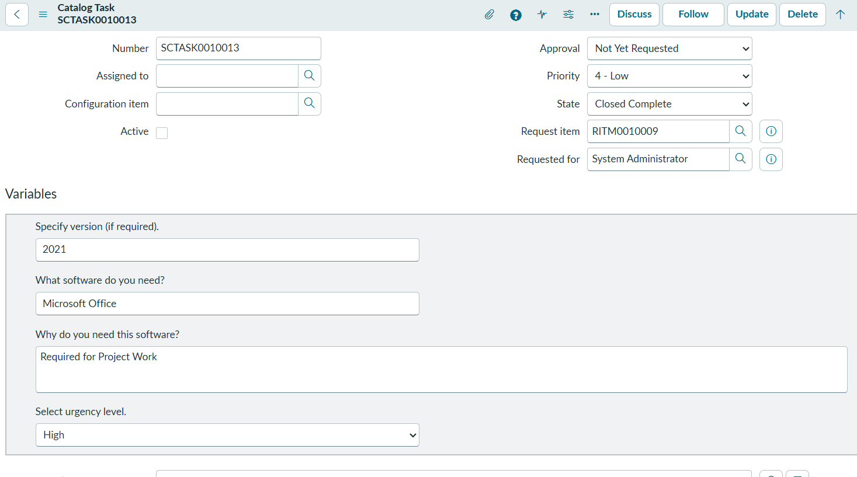
Milestone 6: Business Rules & Update Set Migration

Activity 1: Creating the Business Rule for License Exceptions
- Open ServiceNow.
- Navigate to All and search for System Definition > Business Rules.
- Click New.
- Fill in the primary details:
  - Name: Create Incident on Software License Hold
  - Table: Requested Item [sc_req_item]
  - When: after (Insert/Update)
  - Advanced: Check the Advanced checkbox.
- Under the When to run tab, set the condition:
  - Filter Conditions: [State] [changes to] [On Hold]
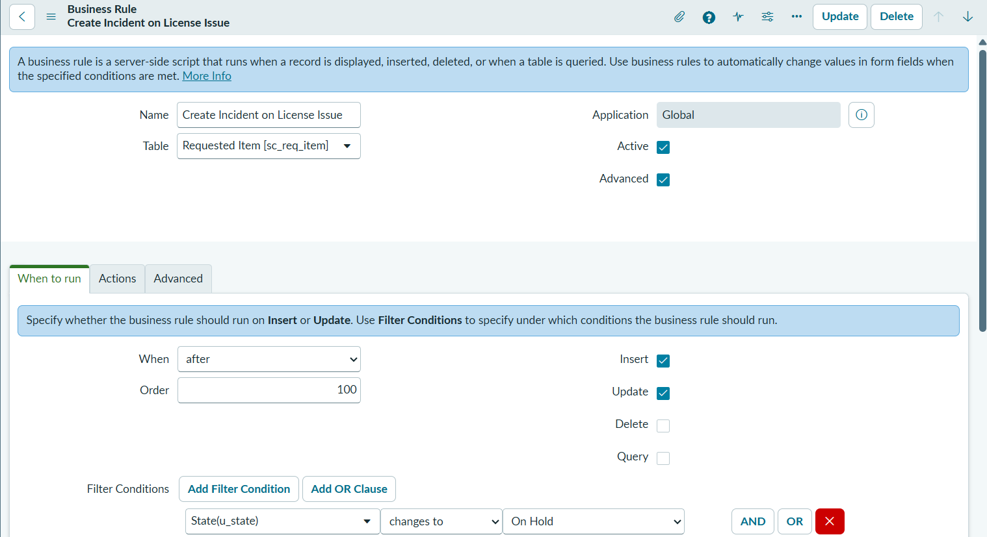

- Click on the Advanced tab and paste the following script into the script editor:

(function executeRule(current, previous /*null when async*/) {

if (current.state == 3) { // 3 represents 'On Hold' state
var inc = new GlideRecord('incident');
inc.initialize();
inc.short_description = 'License unavailable for ' + current.cat_item.getDisplayValue();
inc.description = 'Software request could not be fulfilled due to license shortage.';
inc.caller_id = current.request.requested_for;
inc.assignment_group.setDisplayValue('Software'); // Matched to your assignment group
inc.priority = 3;
inc.insert();
}

})(current, previous);

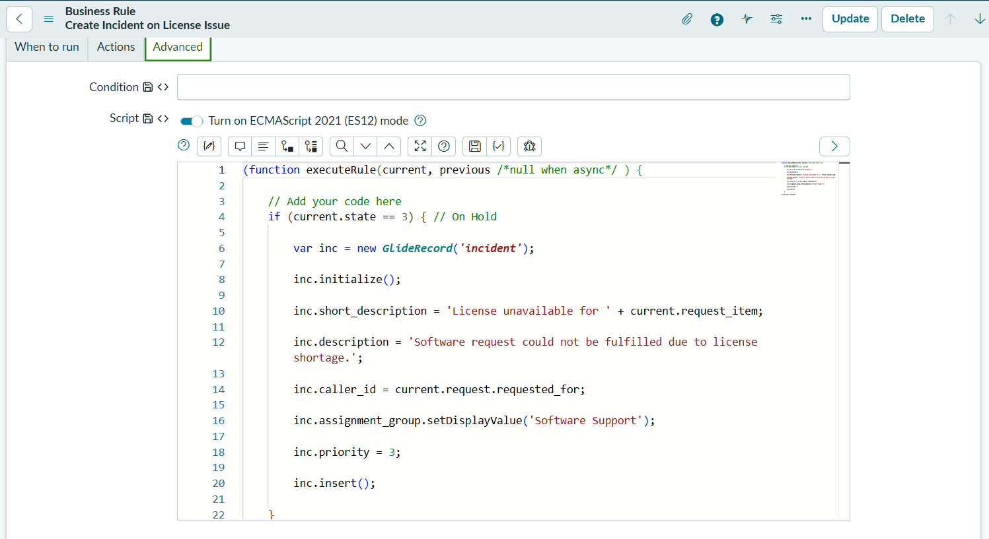
- Click Submit or Save.
Testing: Finalize and Move Update Set

1. Navigate to System Update Sets > Local Update Sets.
2. Open the Update Set created for this project (Software Installation Request Setup).
3. Change the State field from In Progress to Complete.
4. Click Update or Save.
5. Click Export to XML under Related Links.
6. Save the downloaded .xml file to your local computer.
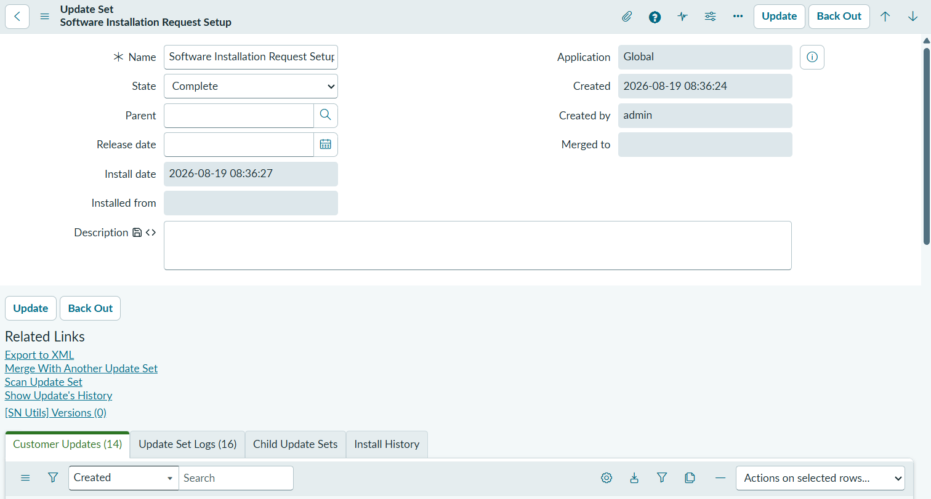

Testing and Committing the Update Set in a Target Instance:
- Open ServiceNow Instance.
- Navigate to System Update Sets > Retrieved Update Sets.
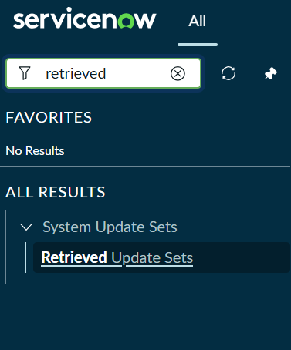
- Under Related Links, click Import Update Set from XML.
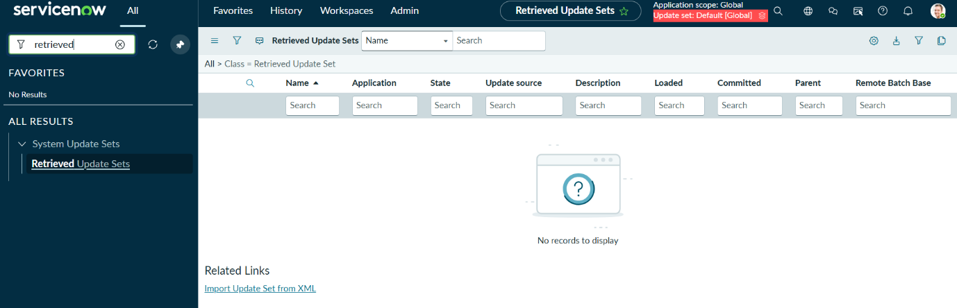
- Click Choose File, select the .xml file downloaded in Activity 2, and click Upload.
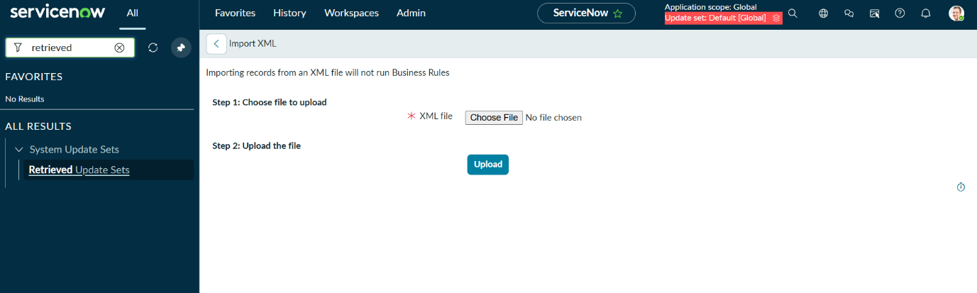
- Open the newly imported record from the Retrieved Update Sets list.
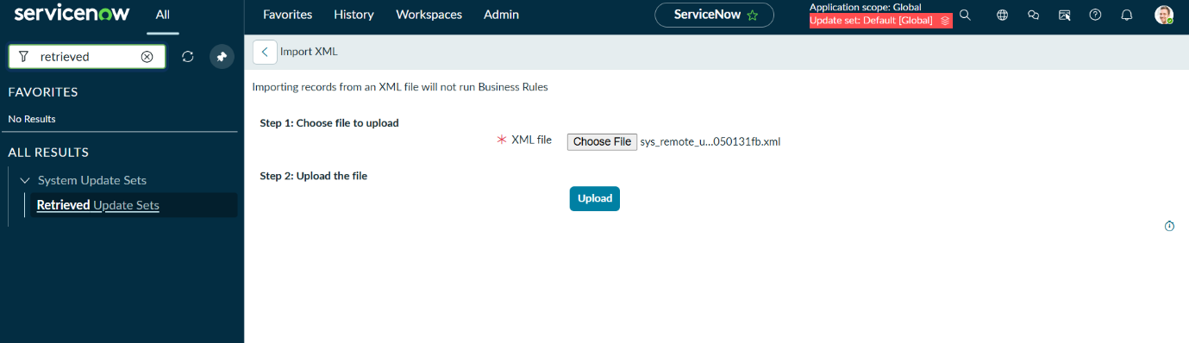
- Click Preview Update Set.
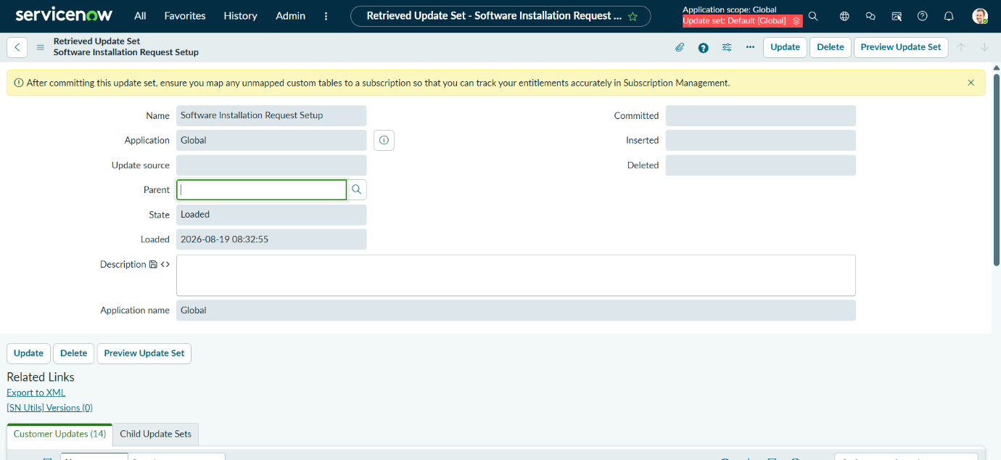
- Review the preview summary to ensure there are no error conflicts.
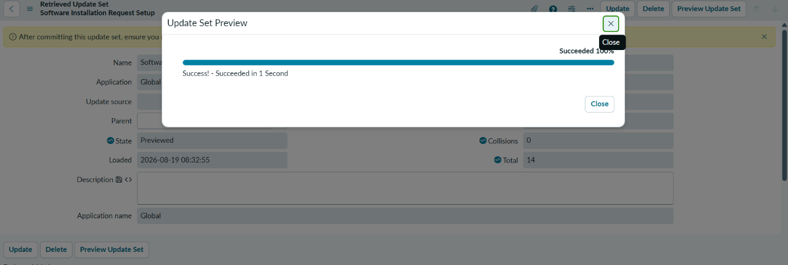
- Click Commit Update Set to apply all configurations to the new instance.
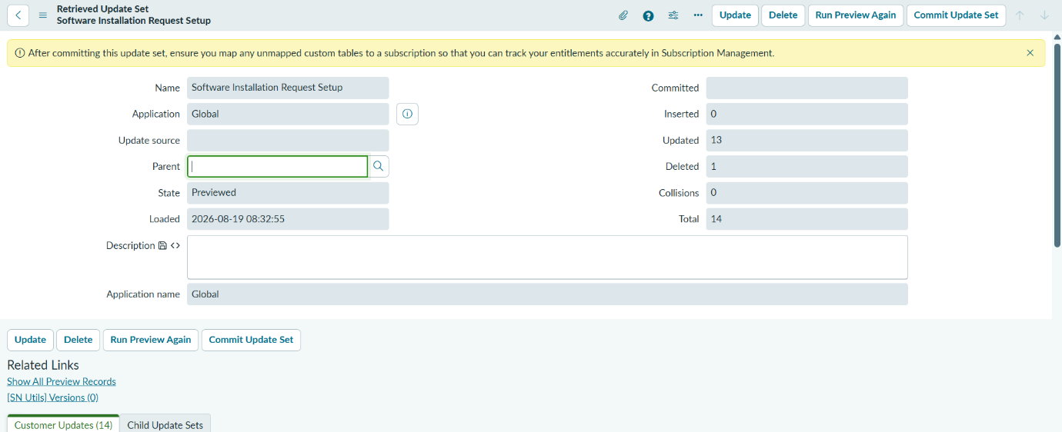

Commit:
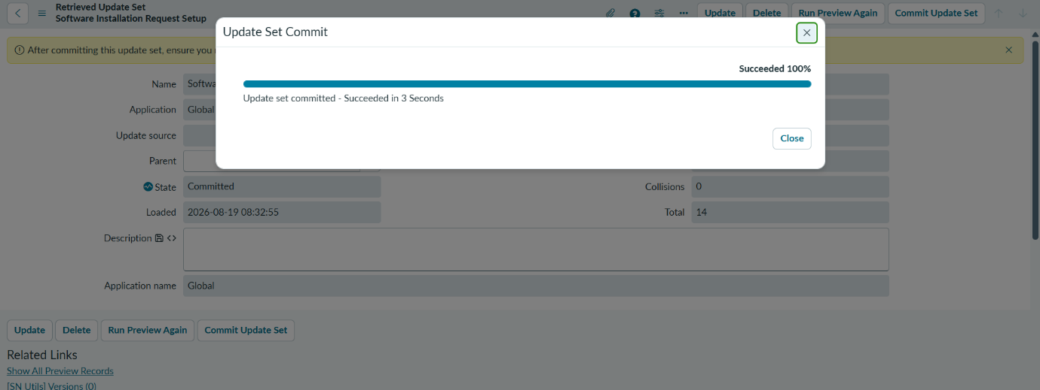
- Verify that all components (Catalog Item, Variables, Flow/Workflow, Business Rule) have transferred successfully.
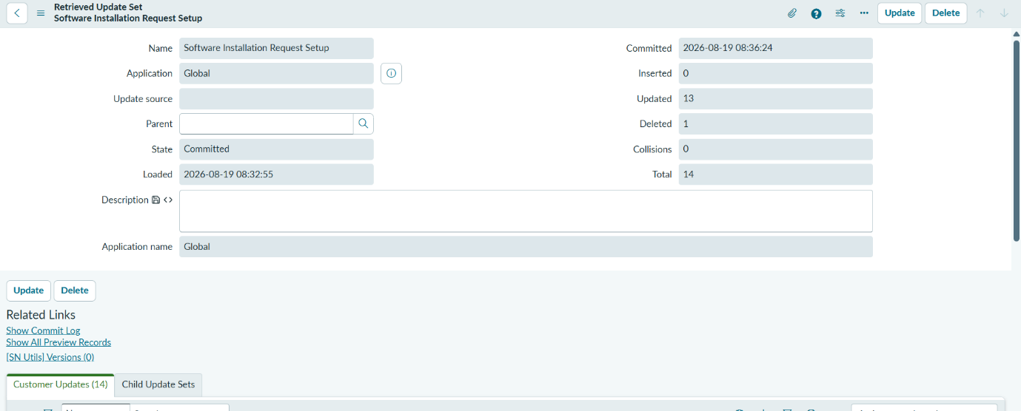

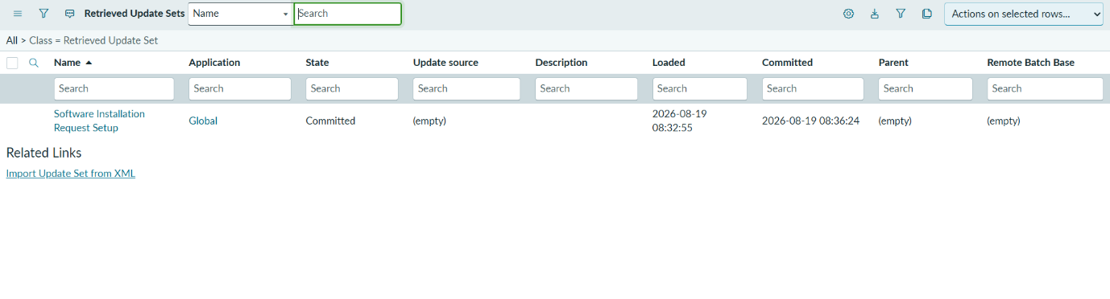
Successfully Uploaded the XML file.

6. Conclusion:
This project successfully automates the enterprise software request lifecycle in ServiceNow using custom Service Catalog components and modern Flow Designer automation. Standardized Catalog items capture end-user requirements with precise variables while triggering dynamic approvals and IT fulfillment tasks. Integrated Business Rules handle licensing exceptions by automatically creating incidents, ensuring operational continuity and complete tracking. Finally, packaging all configurations into Update Sets guarantees seamless migration, portability, and deployment across target environments. Overall, the solution drastically reduces manual tracking errors, enforces process compliance, and improves delivery timelines for software requests.

Thank You 😊

